**How to Choose the Right CCTV System for Your Office in Dubai**

In Dubai, securing your office is paramount. A **CCTV system** is crucial, offering enhanced security, crime prevention, and monitoring. When picking a surveillance system, consider camera type, resolution, and storage. This ensures you get a system that meets your needs.

Choosing the right **CCTV system** can seem overwhelming. However, with the right guidance, you can make a well-informed choice. Assess your office's specific needs, including camera numbers, coverage area, and detail requirements. A suitable system protects your assets, prevents crime, and ensures a safe work environment.

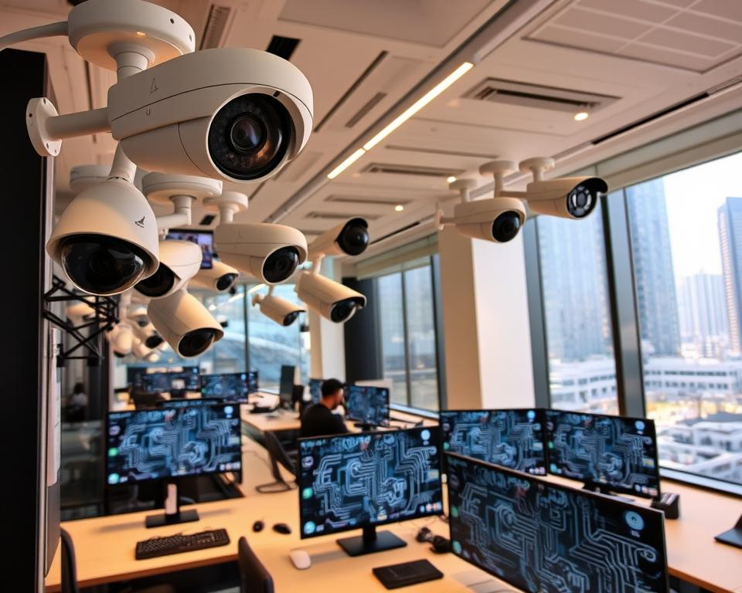

A well-designed **CCTV system** with **surveillance cameras** offers peace of mind. With today's technology, a variety of systems are available, each with unique features. By understanding your needs and researching, you can find the ideal system for your Dubai office.

**Understanding Modern CCTV System Requirements**

For your office in Dubai, grasping the essence of *video surveillance* is vital. You must evaluate the various surveillance camera types, critical security features, and storage options. This knowledge is essential for selecting a CCTV system that aligns with your specific needs.

Regarding *cctv installation*, the selection of **surveillance cameras** is broad. You can choose from IP cameras, analog cameras, and wireless cameras. Each has its own set of benefits and drawbacks, influenced by your security needs. For instance, IP cameras provide high-definition video and remote access ease, whereas analog cameras are more budget-friendly.

**Types of Surveillance Cameras Available**

* IP cameras
* Analog cameras
* Wireless cameras

In the realm of *cctv monitoring*, crucial security features include motion detection, night vision, and weather resistance. These elements are pivotal in swiftly identifying and addressing security risks. Moreover, the choice of video storage and retention, such as DVRs, NVRs, and cloud storage, is also critical.

**Essential Features for Office Security**

When selecting a CCTV system, focus on features like motion detection, night vision, and weather resistance. These attributes are crucial for promptly and effectively addressing security threats.

**Assessing Your Office Security Needs**

To find the perfect *cctv technology* for your office, start by evaluating your security requirements. This means pinpointing weak spots and figuring out how many cameras you need. Think about lighting, weather, and where to place cameras for the best coverage. Adding a *home security camera* to your office setup can significantly boost security and act as a deterrent.

When evaluating your office's security needs, consider several key points:

* Number of entrances and exits
* Valuable assets and equipment
* High-risk areas, such as storage rooms or server rooms
* Employee and visitor traffic patterns

These elements will guide you in deciding on the number and location of cameras, as well as the type of *cctv technology* needed.

It's also crucial to conduct a security audit to spot potential risks and craft a detailed security strategy. This strategy should include setting up *home security camera* systems, along with other security measures like access control and alarm systems.

By carefully assessing your office's security needs and installing the correct *cctv technology* and *home security camera* systems, you can safeguard your business and assets. This ensures a safe and secure environment for everyone at work.

**Key Components of an Effective CCTV System**

Setting up a **business surveillance system** requires careful consideration of several key components. A security camera system's effectiveness hinges on its individual parts. Understanding these components is crucial for making informed decisions about your office's security needs. You aim for high-quality video, reliable coverage, and easy monitoring and recording capabilities.

A well-designed **security camera system** should include high-resolution cameras with wide coverage areas. This reduces the number of cameras needed, saving on costs and simplifying installation and maintenance. Moreover, a robust network infrastructure is essential for supporting your **business surveillance system**. It ensures video feeds are transmitted smoothly and securely.

**Camera Resolution and Coverage Areas**

Camera resolution and coverage areas are critical in determining a security camera system's effectiveness. Choose cameras with high enough resolution to capture clear images, even in low-light conditions. Consider the size of the area you need to monitor and the number of cameras required for adequate coverage.

https://youtube.com/watch?v=L8IoGxwpyW8

**Network Infrastructure Requirements**

A reliable network infrastructure is vital for supporting your **business surveillance system**. It must have sufficient bandwidth to handle video feeds and robust security measures to prevent unauthorized access. Consider factors such as data storage, power supply, and scalability when designing your network infrastructure.

By carefully considering these key components, you can create a comprehensive and effective CCTV system. It meets your office's unique security needs. Whether installing a new system or upgrading an existing one, understanding camera resolution, coverage areas, and network infrastructure is essential. It ensures a secure and safe working environment.

**Dubai Security Regulations and Compliance**

Installing a *cctv system* in your Dubai office requires adherence to local security laws and standards. The Dubai Municipality has specific guidelines for *surveillance cameras*. These are designed to ensure their use is both responsible and effective. It's crucial to follow these regulations to avoid any legal issues.

Key considerations include:

* Obtaining necessary permits and licenses for your *cctv system*
* Ensuring your *surveillance cameras* meet Dubai's technical standards
* Complying with data protection and privacy laws

Following these regulations can significantly enhance your office's security. It also reduces the risk of facing penalties for non-compliance. By understanding and adhering to Dubai's security standards, you can ensure your

Keeping abreast of the latest regulations and standards is essential. This ensures your *surveillance cameras* are used efficiently and responsibly. Doing so helps maintain a secure and compliant office environment in Dubai.

**Implementation and Installation Considerations**

When considering *cctv installation*, you face a choice between professional installation and DIY. While DIY might save costs, professional installation offers expertise, warranty, and support. Experts can guarantee your *cctv technology* is set up right, ensuring a dependable and efficient system.

For a *cctv monitoring* system to work well, it needs regular upkeep. This includes software updates, camera cleaning, and system checks. Choosing professional installation and maintenance means your system will always work right. This gives you the security and peace of mind you need.

**System Scalability Options**

As your business expands, your *cctv technology* should grow with it. Look for systems that can scale, like expanding, upgrading, or integrating with other security systems. This ensures your system meets your evolving needs, offering a future-proof solution.

**Maintenance Requirements**

To keep your *cctv monitoring* system in top shape, regular maintenance is key. This includes:

* Regular software updates
* Camera cleaning
* System checks

By keeping up with these tasks, your system will always operate correctly. This gives you the security and peace of mind you need.

**Conclusion: Making Your Final CCTV Selection**

After delving into the details of selecting the perfect **home security camera** and **business surveillance system** for your Dubai office, it's time to finalize your choice. Assess your office's security needs carefully. Consider camera resolution, coverage areas, and storage needs. Aligning your CCTV system with Dubai's security laws ensures your office is safe and compliant.

Seek advice from security experts to help you choose the right CCTV system for your office. A well-designed and installed system offers significant peace of mind and safeguards your assets. Research thoroughly, compare features, and select a CCTV solution that fits your needs and budget.

**FAQ**

**What are the key benefits of a CCTV system for an office in Dubai?**

A CCTV system boosts office security, prevents crimes, and allows for real-time monitoring. It deters criminal acts, enables live surveillance, and aids in investigations if needed.

**What are the different types of surveillance cameras available for an office CCTV system?**

Office CCTV systems often use IP, analog, and wireless cameras. Each type offers unique benefits. It's crucial to match your needs with the right camera technology.

**What are the essential features to look for in an office security CCTV system?**

Key features include motion detection, night vision, weather resistance, and high-resolution images. These ensure your system effectively monitors and records your office environment.

**How much video storage and retention is required for an office CCTV system?**

The storage and retention needs depend on camera numbers, resolution, and frame rate. Consider DVRs, NVRs, or cloud storage for sufficient capacity.

**How do I assess the security needs of my office to determine the right CCTV system?**

Start with a thorough security audit to identify vulnerabilities. This will guide you in choosing the right camera numbers, placement, and features for your office's protection.

**What are the key components of an effective CCTV system for an office in Dubai?**

An effective system includes high-resolution cameras, reliable networks, and proper monitoring and recording tools. These elements ensure comprehensive security tailored to your office's needs.

**What are the security regulations and compliance requirements for CCTV systems in Dubai?**

Dubai has specific CCTV regulations set by the Dubai Municipality. Understanding these is crucial to avoid legal and financial issues.

**Should I opt for a professional installation or a DIY approach for my office CCTV system?**

Choosing between professional installation and DIY depends on your technical skills, system complexity, and support needs. Professional installation offers expertise, warranty, and ongoing support, while DIY may save costs but requires more technical knowledge.

✅ Certified Technicians  
✅ Quick & Reliable Service  
✅ Compliance with Industry Standards  
✅ Cost-Effective Solutions

High-Quality Spare Parts & Calibration